COMP3023 Design and Analysis of Algorithms
Spring 2026
Assignment 1

Question 1:
Given the input $A=\left[2,-7,3,1,2,-3,5,-4,6,2\right]$, track the divide-and-conquer algorithm to find the maximum contiguous subarray. Construct the recursive calls as a tree. (20pt)

Ans:
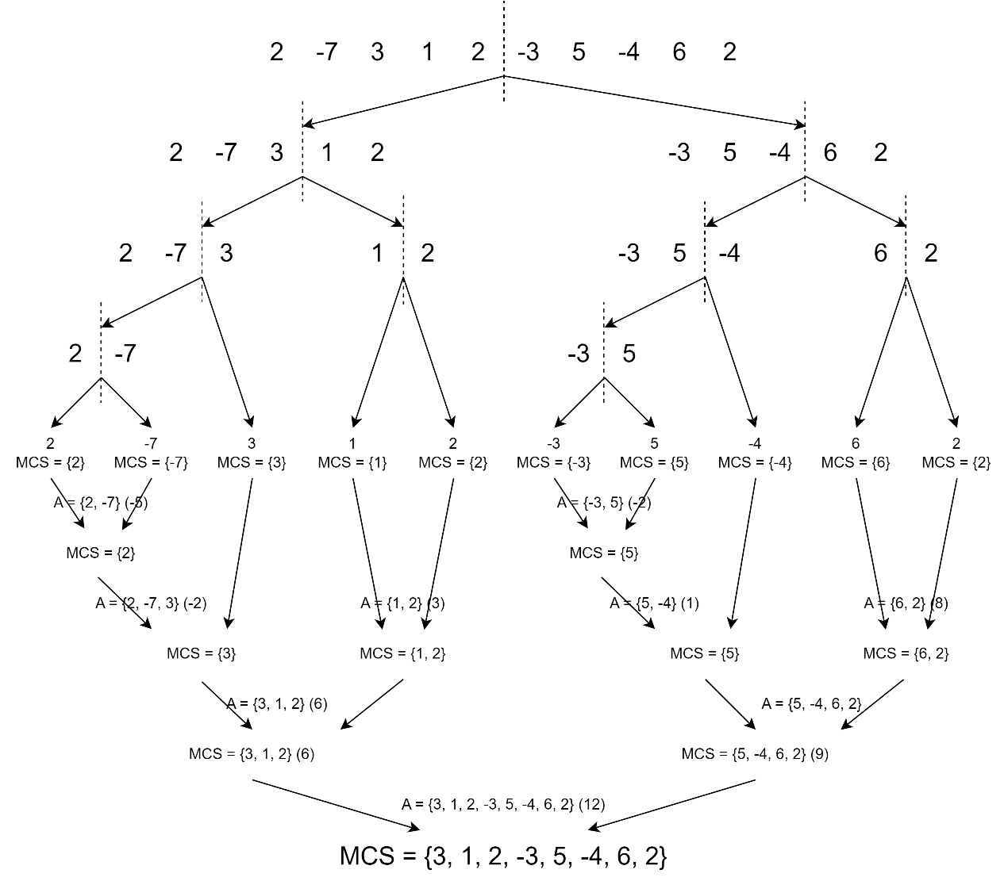

Question 2:
Given two polynomials $A\left(x\right)=2+3x+x^{2}+2x^{3}+x^{4}$ and $B\left(x\right)=x+4x^{2}+2x^{4}$, track the $O\left(n^{\log{3}}\right)$ algorithm to calculate $A\left(x\right)×B\left(x\right)$. Construct the recursive calls as a tree. (25pt)
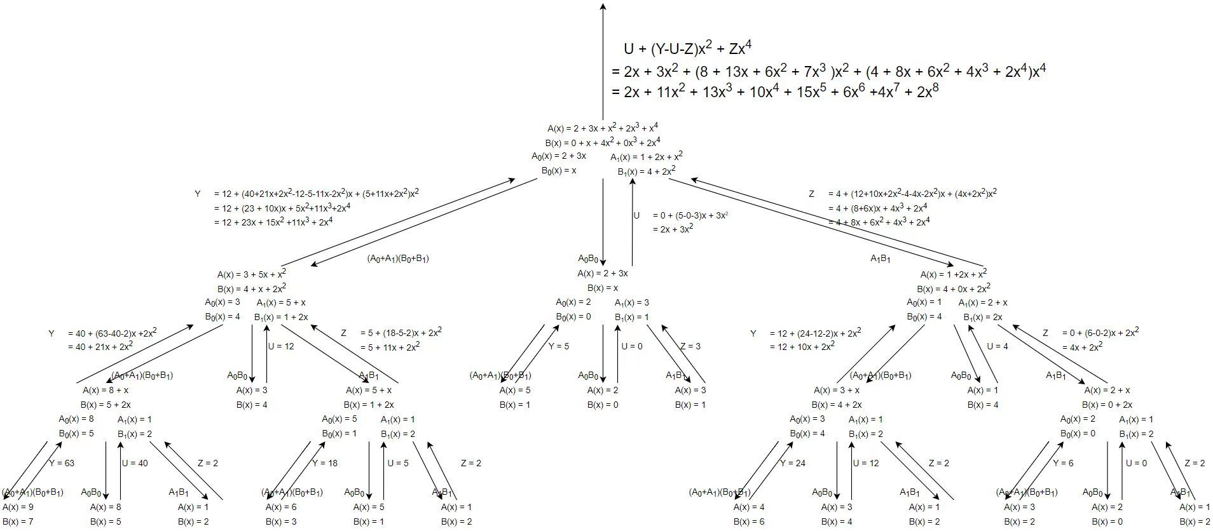
Ans: (Give $A_{0}$, $A_{1},B_{0},B_{1},Y,U,$ and $Z$ in each iteration)

Question 3.
Please use the method in $DSelection$ to find the median of medians recursively on the following array $A$ in groups of 5. (15pt)
$A=$ $(22,33,17,23,9,31,16,21,26,4,1,13,3,24,20,14,2,30,18,6,40,15,5,38,35,7,$
$$12,29,34,27,36,39,8,28,32,19,37,25,10,11)$$
Ans:
Iteration 1.
$$22$$ | $$31$$ | $$1$$ | $$14$$ | $$40$$ | $$7$$ | $$36$$ | $$19$$
$$33$$ | $$16$$ | $$13$$ | $$2$$ | $$15$$ | $$12$$ | $$39$$ | $$37$$
$$17$$ | $$21$$ | $$3$$ | $$30$$ | $$5$$ | $$29$$ | $$8$$ | $$25$$
$$23$$ | $$26$$ | $$24$$ | $$18$$ | $$38$$ | $$34$$ | $$28$$ | $$10$$
$$9$$ | $$4$$ | $$20$$ | $$6$$ | $$35$$ | $$27$$ | $$32$$ | $$11$$

Iteration 2.
Recursive call: $DSelection\left(\left(22,21,13,14,35,27,32,19\right),4\right)$
The result of this recursive call is the median of medians.
$$22$$ | $$27$$
$$21$$ | $$32$$
$$13$$ | $$19$$
$$14$$
$$35$$

Iteration 3.
Recursive call: $DSelection\left(\left(21,27\right),1\right)$
$$21$$
$$27$$

Return $21$
Back to Iteration 2.
Use 21 is the pivot and partition $\left(22,21,13,14,35,27,32,19\right)$
$Left=(13,14,19)$, $Right=(22,35,27,32)$
The pivot hits the 4th smallest. Thus, 21 is the median of medians.

Question 4.
Present the deterministic linear-time selection algorithm $DSelection\left(A,p,r,i\right)$ in Lecture 5 as pseudo codes. The interface of $DSelection$ is as
You are allowed to make function calls to $Partition$, which is defined as
Please also pay attention to the interface of Algorithm 2.
- The input needs one extra argument $m$, to specify which element is selected as the pivot (not randomly, not the last element).
- The output is the index of the pivot (after permutation) instead of its value.
- After executing the algorithm, the input array $A$ becomes $A'$ (as a side-effect), which satisfies the partition property.
To simplify your pseudocodes, you are also to use $GroupF$ and $Median$, which are defined as

These specifications will make your algorithm consistent. (20pt)
Ans.

Question 5.
Mr. Trivial wants to design an algorithm to find MCS. He has realized the following.
Observation 1.
Each array $A\left[0⋯n-1\right]$ can be split into three subarrays $L=A\left[0⋯i-1\right]$, $M=A\left[i⋯j\right]$, and $R=A\left[j+1⋯n-1\right]$ such that $0≤i≤j≤n-1$ (when $i=0$, $L$ is an empty array; and same for $j=n-1$).
Observation 2.
If $M$ is the MCS of $A$, then $L$ is the minimum prefix of $A$ and $R$ is the minimum suffix of $A$.
Example.
For example, $A=\left[1,-3,4,2,-2,1\right]$. The minimum prefix is $L=\left[1,-3\right]$; the minimum suffix is $R=\left[-2,1\right]$; and the MCS is $M=\left[4,2\right]$.

However, these two observations are not generally true. Thus,
- Prove that Observation 2 is false. (5pt)
- Claim a correct observation. (5pt)
- Use the observation in Part b) to design a divide-and-conquer algorithm to find the MCS. Your algorithm should
  - run in $O\left(n\log{n}\right)$ time;
  - must use $MinPrefix( )$ and $MinSuffix( )$ which find the value of the minimum prefix and suffix of an input array;
  - cannot use or implement $MaxPrefix( )$ and $MaxSuffix( )$ (Algorithm 3 on page 16 of Lecture 02); and
  - be presented as pseudo codes. (5pt)
- Show your algorithm runs in $O\left(n\log{n}\right)$ time. (5pt)

Ans:
- Proof (by counter example):
Let $A=\left[-2,1,-2\right]$, the MCS of $A$ is $M=[1]$. However, following Mr. Trivial’s observation, the minimum prefix of $A$ is $L=\left[-2,1,-2\right]$, and the minimum suffix of $A$ is $R=\left[-2,1 -2\right]$. Then, the value of MCS cannot be calculated from $sum\left(A\right)-sum\left(L\right)-sum\left(R\right)$. Therefore, Observation 2 does not hold in general.
- From a), we see that a bug happens when $L$ goes to the second half of $A$ (or $R$ goes to the first half of $A$). In other words, this strategy only works when the MCS goes across the middle. If MCS is fully contained in the first half of $A$, the correct solution is obtained when $L$ (and $R$) is the minimum prefix (suffix) of the first half of $A$. Thus, the valid observation is
Observation 3.
If the MCS goes across the middle (contains $A\left[\left\lfloor \frac{n}{2}\right\rfloor \right]$ and $A\left[\left\lfloor \frac{n}{2}\right\rfloor +1\right]$), $L$ is the minimum prefix of the first half $A\left[0,⋯,\left\lfloor \frac{n}{2}\right\rfloor -1\right]$ and $R$ is the minimum suffix of the second half $A\left[\left\lfloor \frac{n}{2}\right\rfloor +2,⋯, n-1\right]$.
- Observation 3 only discusses the case when the MCS goes across the middle. If it is in the first half (or second half), the algorithm simply makes recursive calls.
We assume that $MinPrefix(R,i,j)$ and $MinSuffix(R,i,j)$ are robust when inputs are extreme cases. For example, $MinPrefix\left(R,i,j\right)=0$ when $i>j$ or every non-empty prefix is positive.

$T\left(n\right)=1$ if $n=1$
$T\left(n\right)=2T\left(\frac{n}{2}\right)+2n+4$ if $n≥2$
Solve the recurrence relation
$T(n)$ $=2T\left(\frac{n}{2}\right)+2n+4$
$=2\left[2T\left(\frac{n}{2^{2}}\right)+2\frac{n}{2}+4\right]+2n+4$
$=2^{2}T\left(\frac{n}{2^{2}}\right)+2×2n+4×\left(2+1\right)$
$=2^{2}\left[2T\left(\frac{n}{2^{3}}\right)+2\frac{n}{2^{2}}+4\right]+2n+2×4+2n+4$
$=2^{3}T\left(\frac{n}{2^{3}}\right)+3×2n+4\left(2^{2}+2+1\right)$
$⋮$
$=2^{i}T\left(\frac{n}{2^{i}}\right)+2ni+4(2^{i-1}+⋯+1)$
Let $i=\log{n}$.
$T(n)$ $=nT\left(1\right)+2n\log{n}+4(n-1)$
$=n+2n\log{n+4n-4}$
$=O\left(n\log{n}\right)$

